AWS REBUILD WALKTHROUGH

- Main S3 Bucket
Used for uploading test images, triggering the Lambda, connecting the interface and verifying my pipeline.
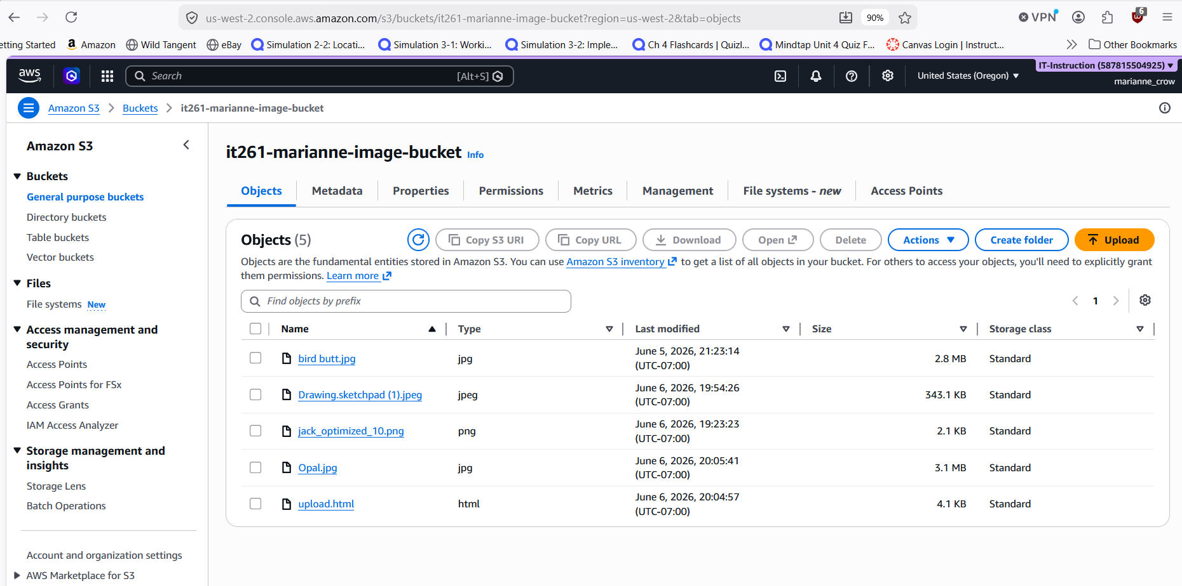
Image 1.1: The details and contents of the “it261-marianne-image-bucket” bucket
- IAM Role
This IAM role was autogenerated by AWS when I created the Lambda function. The role allows the Lambda function to read from the S3 bucket and write logs to CloudWatch.

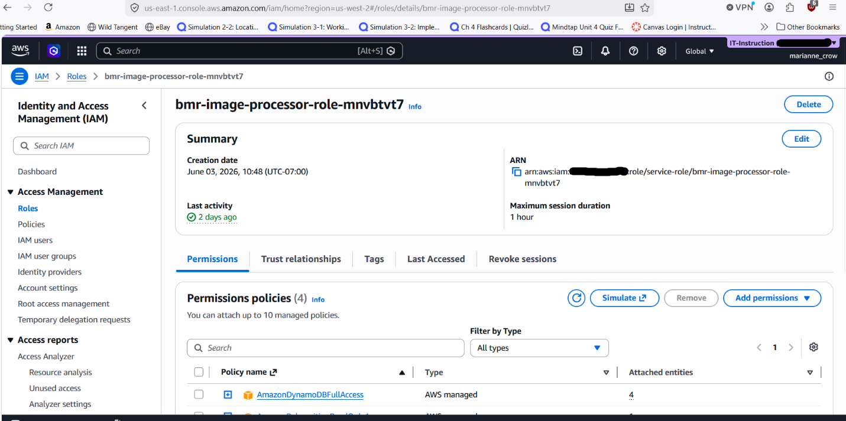
Image 2.1: The details page for the “bmr-image-processor-role-mnvbtvt7” IAM role.
- Lambda Function

I created the Lambda function it261-marianne-image-processor using Python 3.14. AWS autogenerated the execution role bmr-image-processor-role-mnvbtvt7, which allows the function to read from the S3 bucket and write logs to CloudWatch.

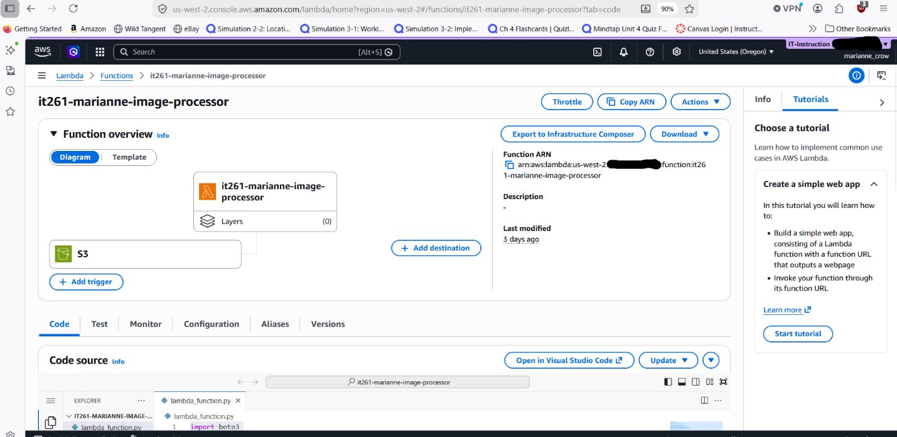
Image 3.1: Overview of the “it261-marianne-image-processor” lambda function

This screenshot shows the Lambda Code Source tab with the file lambda_function.py open in the editor. It displays the full Python code used by the function, confirming that the Lambda was rebuilt correctly and that the processing logic is present and accessible in the code editor.
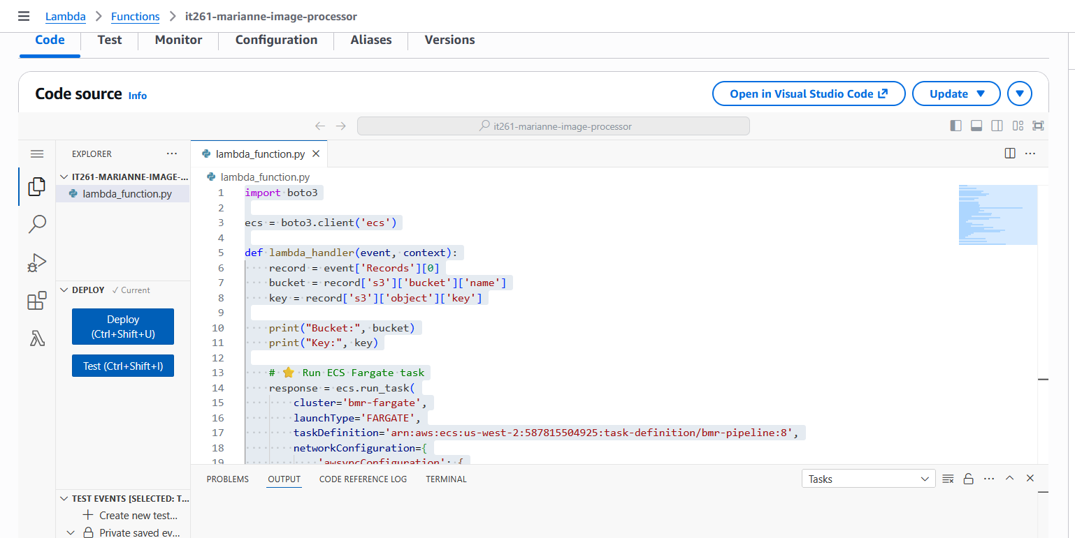
Image 3.2: The AWS Code Editor with the lambda_function.py file open

This screenshot shows the Permissions section of my Lambda function it261-marianne-image-processor, specifically highlighting the execution role bmr-image-processor-role-mnvbtvt7 that AWS automatically attached when the function was created. This screen is important because it confirms that the Lambda function is using the correct IAM role, which provides the necessary permissions to read from the S3 bucket, write processed files to the output bucket, and send logs to CloudWatch. Without this role, the function would not be able to access the resources required for the pipeline to work.
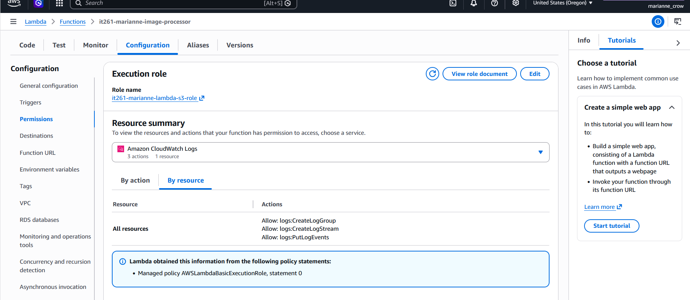
Image 3.3: The Permissions tab of the lambda is open, showcasing its Execution Role
4. S3 Trigger
This screenshot shows the S3 trigger attached to my Lambda function it261-marianne-image-processor on the Configuration → Triggers page. The green S3 bucket icon labeled it261-marianne-image-bucket confirms that the function is correctly configured to run automatically whenever a new object is uploaded to the bucket. This screen is important because it verifies that the event notification is active and that the Lambda will be invoked on each PUT (Object Created) event, which is required for the pipeline to function.
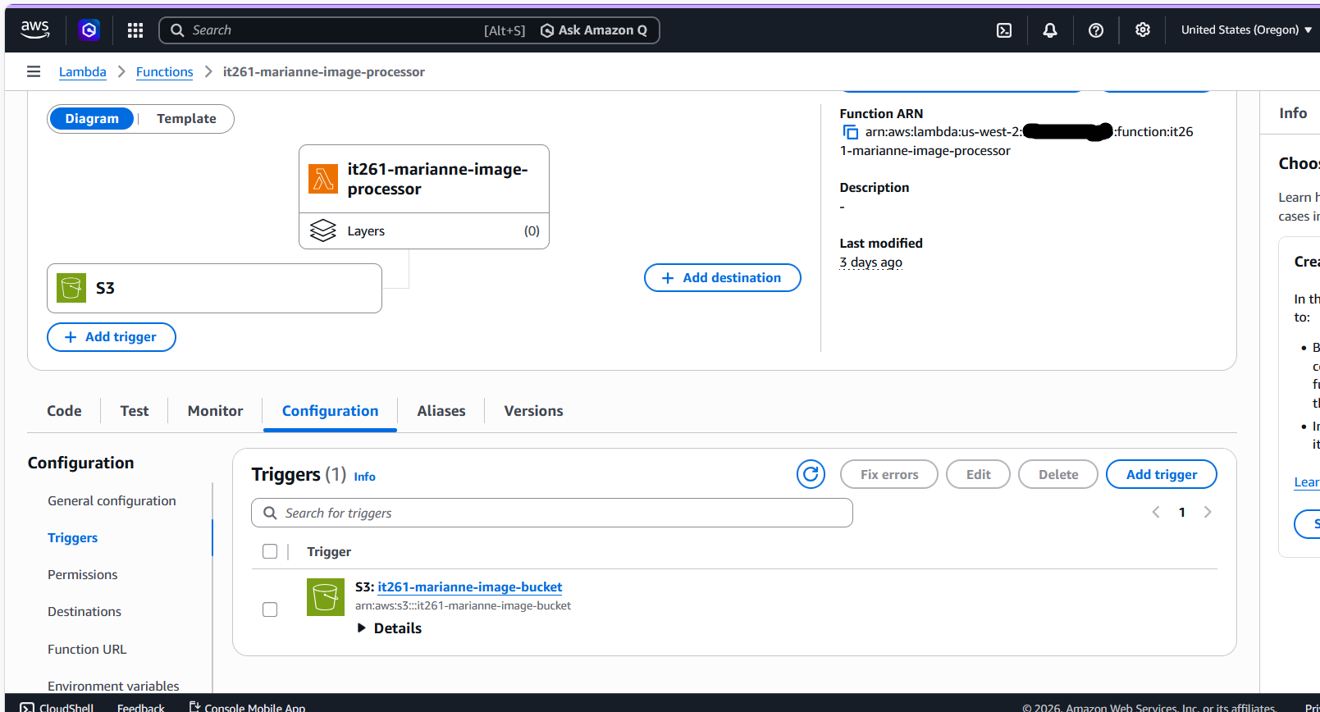
Image 4.1: Overview of my lambda function, showing my S3 bucket attached as a Trigger

This screenshot shows the Resource-based policy statements for my Lambda function it261-marianne-image-processor. This view is important because it confirms that Amazon S3 is explicitly allowed to invoke the Lambda function through its resource policy. Without this permission, the S3 trigger would not be able to call the function, and the pipeline would fail at the event-notification stage.
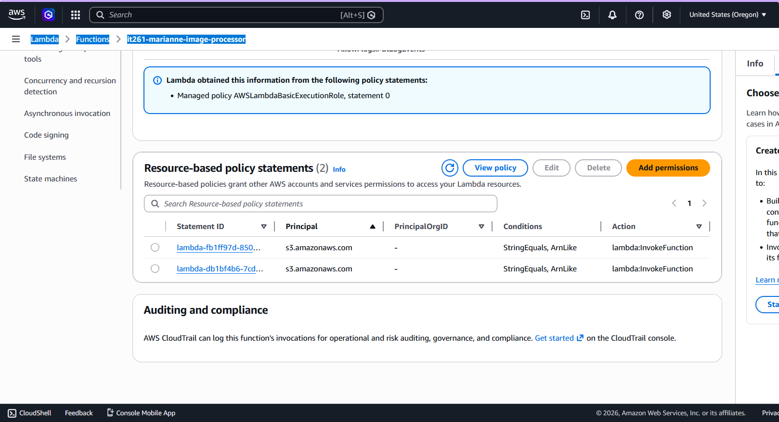
Image 4.2: Resource-Based Policy Statements tab for my lambda function, showing 2 policies are currently attached

This screenshot shows the Lambda function it261-marianne-image-processor with the Code tab selected while the Function Overview diagram remains visible, including the green S3 bucket trigger icon. This screen is important because it demonstrates that the function’s code, configuration, and S3 trigger are all correctly connected and active in the same view, confirming that the Lambda is fully wired to receive events and execute the processing logic.
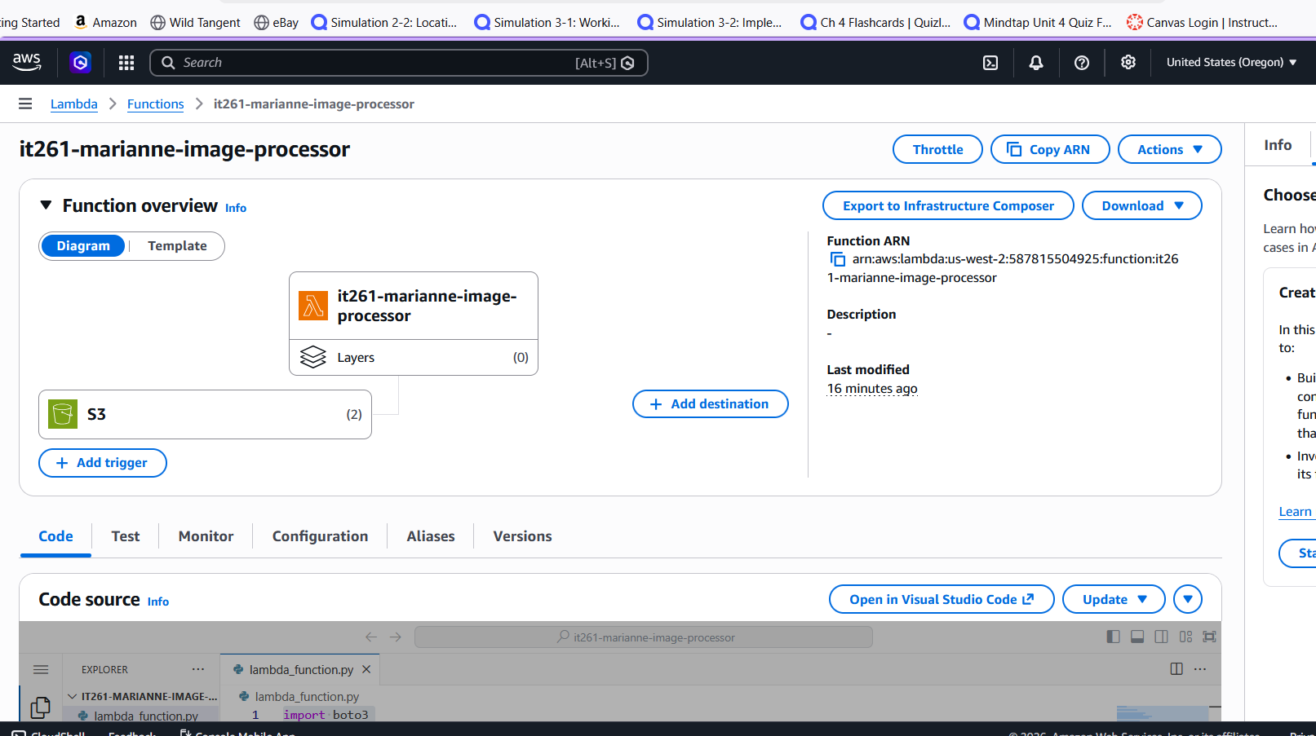
Image 4.3: Function Overview showing the attached S3 Trigger while the Code tab is selected
5. Output Bucket
This screenshot shows my output S3 bucket it261-marianne-output, which stores the processed images generated by the Lambda function. The three files listed—processed-baker.jpg, processed-jack_optimized_10.png, and processed-Opal.jpg—confirm that the Lambda successfully processed the uploaded images and wrote the results to the correct destination bucket. This verifies that the final stage of the pipeline is functioning as intended.

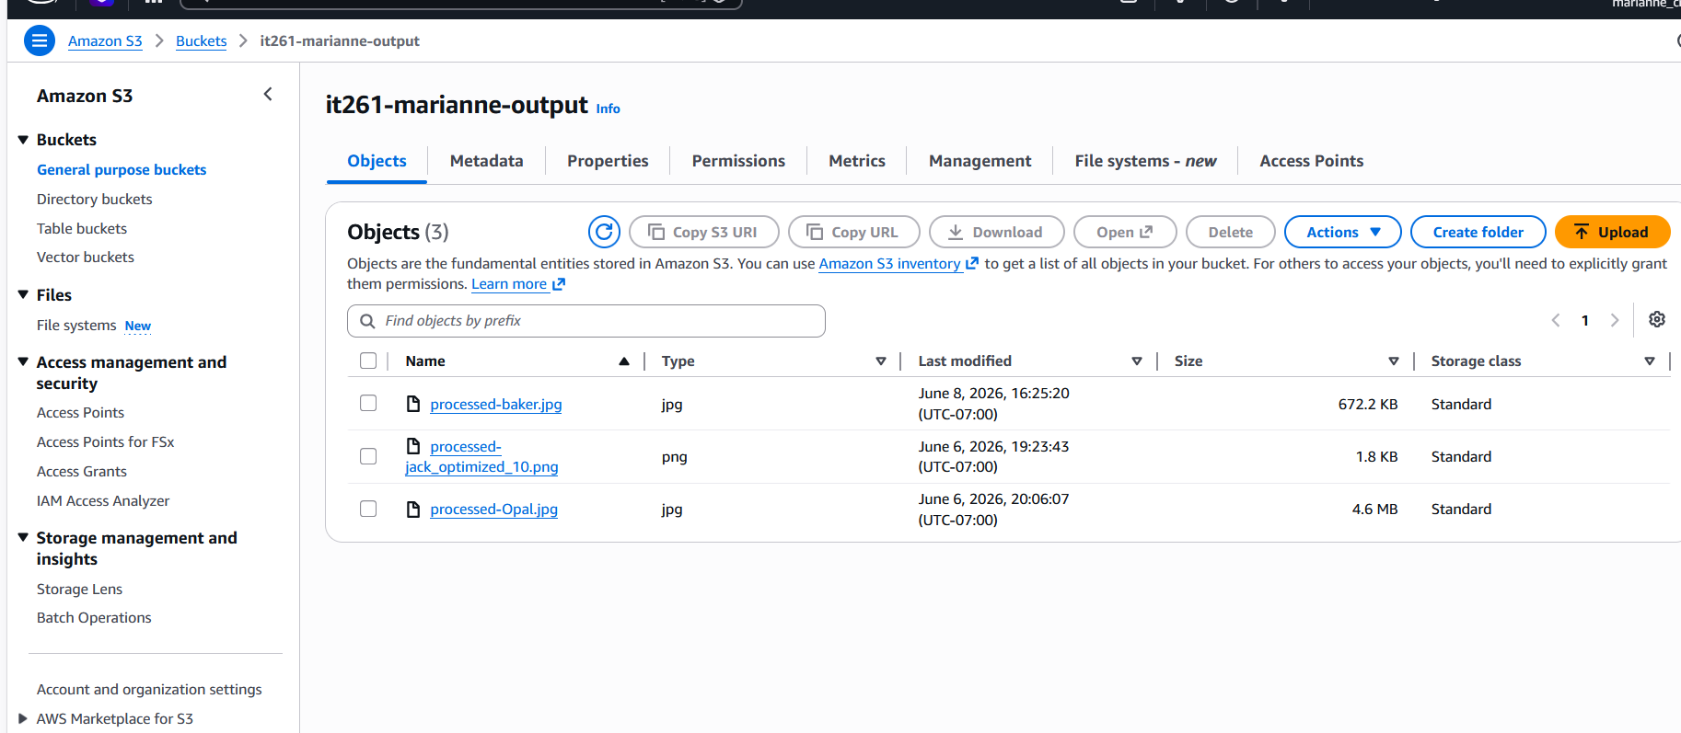
Image 5.1: The contents of the output bucket after several files have been uploaded
6. Web Interface
The first screenshot shows my S3-hosted web interface in its initial state, with the file-upload control visible before selecting an image. The second screenshot shows the interface after I browsed and selected a .jpg file to upload, confirming that the page correctly accepts user input and prepares the file for submission to the pipeline. The third screenshot shows the successful result after the upload completed, displaying the processed image of my cat Opal that was retrieved from the output bucket. Together, these screenshots demonstrate that the full end-to-end workflow—from selecting an image, to uploading it through the interface, to Lambda processing, to retrieving the final processed image—worked exactly as intended.
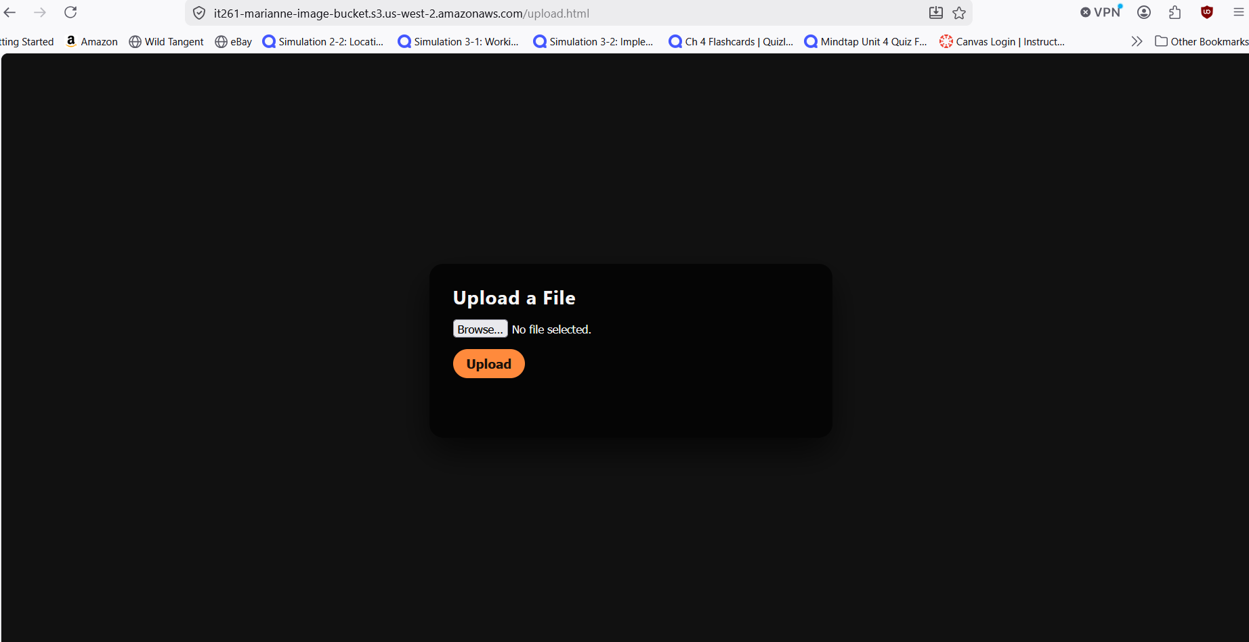
Image 6.1: The upload interface open in a browser
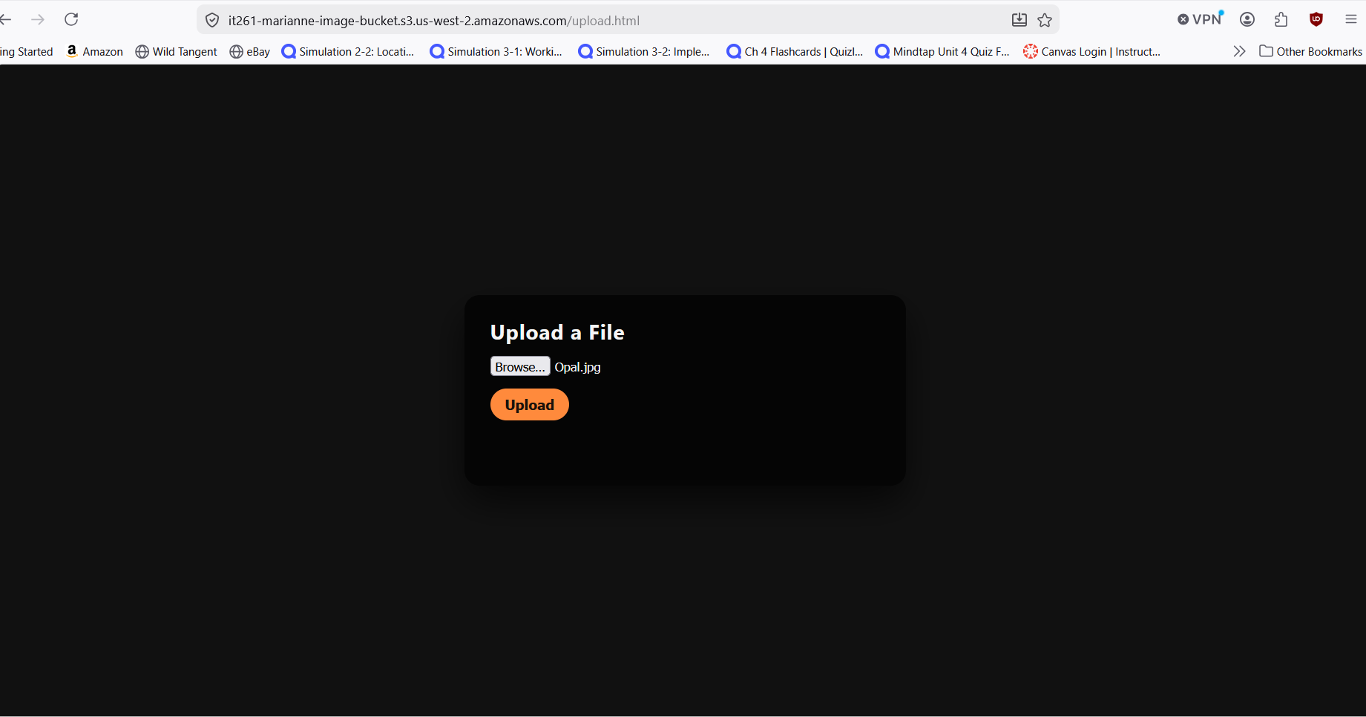
Image 6.2: The upload interface after an image has been selected to be uploaded

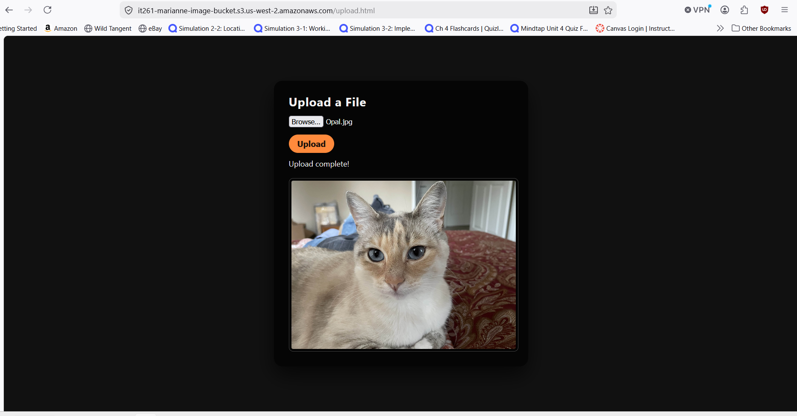
Image 6.3: The upload interface after uploading the selected image. After an image has been uploaded successfully, the interface displays a preview of the image.

